ARCHIVE
On-line
Storage and Retrieval

for the

FACTS Version 7.4 Software System

ARCHIVE (c) 1993 Earnest and Associates. All Rights Reserved.

FACTS (c) 1986, 1990, 1992 APERUM, Inc. All Rights Reserved
ProvideX ® is a trademark of Best Software Canada Ltd., Ontario, Canada

Table of Contents:

System Overview................................................................................1

Using ARCHIVE to Store Output........................................................3

Main Menu Options.............................................................................5

ARCHIVE View..................................................................................6

ARCHIVE Print..................................................................................10

ARCHIVE Store.................................................................................11.

ARCHIVE List............................................................................................13

ARCHIVE Indexer......................................................................................15

ARCHIVE Backup/Restore.........................................................................16

ARCHIVE Catalog Rebuilder.......................................................................17

ARCHIVE Removal.....................................................................................18

ARCHIVE FM’S and Utilities ………………………………………………19

ARCHIVE Catalog F/M......................................................................20

ARCHIVE Control F/M...............................................................................22

ARCHIVE GUI Search FM ………………………………………………....26

ARCHIVE Utilities ………………………………………………………….27

SYSTEM OVERVIEW

Introduction

Today’s businesses are plagued by the sky-rocketing costs of storing and maintaining the vast number of documents and the mountains of output report data required for day-to-day operations. Technology has, however, offered businesses a solution: On-line document storage and retrieval. Rooms once filled with filing cabinets give way to cost effective, high capacity disk drives as on-line storage becomes more of the norm, rather than the exception. With the “paperless office” as the goal of the near future, on-line document storage and retrieval couples safe, cost effective storage with the flexibility of instant access from any terminal.

The ARCHIVE Sub-System provides FACTS users with on-line storage and retrieval capabilities for any reports or prints generated through the system. ARCHIVE goes a step further by allowing users to store non-FACTS text data generated through report writers, word processors, spreadsheets, etc. The ARCHIVE interface is fully integrated into the standard FACTS printer selection system, making it as simple as selecting a printer. The ARCHIVE ‘printer’ can also be defined as a default printer within the Program F/M, thus not requiring a printer selection box to activate. ARCHIVE also provides the capability to store output from Job Streams without requiring any additional input from the user.

Once ARCHIVEd, output data can be viewed, searched on, and/or printed as often as required, from any terminal on the system. ARCHIVEd data of up to 255 columns can be viewed on a terminal in an 80 column format, providing easy to read data, while providing the user with the ability to pan left and right to view the output. Within the view mode, users can execute searches for specific data, with any matches returned high lighted with in the context of the output. Users are also provided with the capability to print all or part of any ARCHIVEd output file.

The ARCHIVE Sub-System also provides an ARCHIVE Listing program, allowing users to list all stored output, either by ARCHIVE number or by FACTS program designation. Search capabilities are also provided in most ARCHIVE access programs. Each ARCHIVE is represented by a catalog record in the Catalog F/M, which maintains the attributes of each stored file, including the program name and description, date and time of creation, and the user who created it, along with the security level, library directory name, and any memos entered by the user.

ARCHIVE files are stored as text files, allowing for maximum compression. To facilitate the viewing of these files, the ARCHIVE sub-system creates temporary index files to enhance both speed and functionality. These index files are created 'on-the-fly' within the view program, unless they have been previously created using the ARCHIVE Indexer program. The ARCHIVE Control F/M has a flag to control whether or not these temporary files are removed upon exiting the view program. If the flag is set to 'N', then the temporary files will remain in the work directory until removed by the system administrator. (The installation instructions outline a method of automating the removal of these index files.) When selecting to view a specific ARCHIVE, the program will first check to see if an index file exists, and if so, will go immediately into view mode.

The ARCHIVE Catalog Rebuilder provides users an automated way of recreating an ARCHIVE Catalog F/M record, in case the original record has been inadvertently removed, or has become corrupt. This program allows the user to search through any and all library directories, and select files to re-add to the Catalog F/M. (The data stored in the F/M is also stored within each ARCHIVE file, allowing the records to be recreated easily.)

The ARCHIVE Backup and Restore programs provide users with the means to select certain Archives to be stored in and retrieved from tape or diskette libraries, freeing up disk space for more current ARCHIVES. This feature is not available in Windows/NT.

A removal program is also included, allowing users to delete 'obsolete' output by ARCHIVE number, program designation, and/or creation date.

The ARCHIVE Control F/M provides flexibility by allowing users to determine where on their system they wish to store the ARCHIVEd data, as well as providing compression options and password control for removals and deletions.

NOTE: All screens and descriptions contained hereafter pertain to GUI users, unless
otherwise noted. The character mode programs function in the same fashion as
previous releases of the product

Using ARCHIVE to Store Output

To activate, simply change the printer selection to ARCHIVE. Upon starting the report, the following window appears...

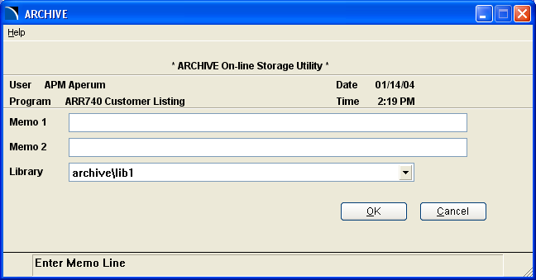

If the program is a standard FACTS register that utilizes a register number and the date of the register is equal to a register on file, then the user will be given an option to delete the duplicate Archived register.

The user can enter optional memo lines further describing the output. These memos, along with the program and user information and the date/time stamp, will be carried through to the Catalog F/M. The Library selection involves using the default library or choosing, from a selection box, the directory in which to store this ARCHIVE. Up to six library directories may be defined in the ARCHIVE Control F/M.

Upon selection of a storage library, the user can click “OK” to begin the ARCHIVE. If the user wishes to cancel the ARCHIVE at this point, “CANCEL” will return the user to the FACTS report selection box.

From this point forward, the ARCHIVE Sub-System functions behind the scenes in a completely automated fashion. The only additional inputs required will appear at the completion of the report/print, where the user will be asked if it is "OK to Complete the ARCHIVE." This option is provided in case the user decides, after the output is generated, that he/she does not wish to 'keep' the ARCHIVE, for whatever reason. This optional question can be eliminated by setting the 'auto-update' flag within the ARCHIVE Control F/M. Regardless of the setting of this flag, if ARCHIVE determines that an error or escape has been detected, the user will be warned and given the option to complete or abort the ARCHIVE process. (Archives created through Job Stream runs are assigned defaults, thus requiring no windowed interface.). User has an additional input option to print the Archive. We recommend printing a hard copy of all Archived registers in case loss of data occurs before the nightly backup is performed.
Main Menu Options

The main menu of the ARCHIVE Sub-System appears as follows...

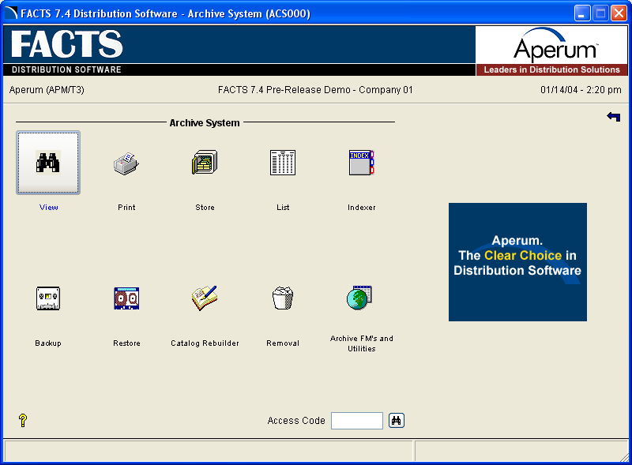

ARCHIVE View - View, search on, and print ARCHIVEd data.
ARCHIVE Print - Print individual or multiple Archives.
ARCHIVE Store - ARCHIVE non-FACTS text data.
ARCHIVE Lister - List the attributes of any or all Archives in the system.
ARCHIVE Indexer - Predefine view mode index files.
ARCHIVE Backup - Store Archives to tape or diskette.
ARCHIVE Restore - Restore Archives previously stored to tape or diskette.
ARCHIVE Catalog F/M - Maintain/Delete individual ARCHIVE records.
ARCHIVE Catalog Rebuilder - Re-create missing Catalog F/M records.
ARCHIVE Removal - Remove unwanted/outdated Archives.
ARCHIVE FM’s and Utilities – Sub menu of FM’s and Utilities

The following pages contain overviews and instructions for using each of the programs listed above.
ARCHIVE View (ACI111)

The ARCHIVE View program allows the user to view, search on and print all, or part of, any stored file. The initial screen prompts the user to enter an ARCHIVE number to view. A search by program designation is available if the number of the ARCHIVE to view is not known.

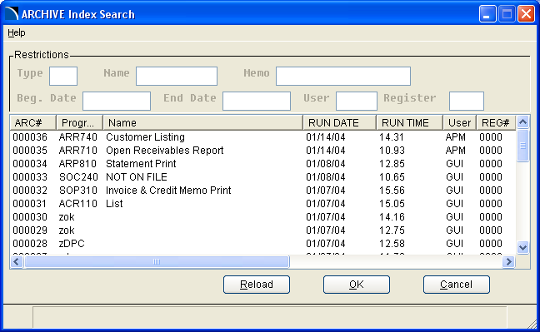

From within the search window the user mouse clicks to set restrictions for the search.

TYPE: Enter in a valid module/program type combination. IE. ‘SOR’ will display sales order reports only. The third character must be an R or P.

NAME: Enter the report name or a portion of the name to further filter the search. For example: ‘DAILY’ will display all Daily Sales Registers. Upper or lower case is supported and will filter properly.

MEMO: Enter a phrase to scan against Archive memos.

DATES: Enter a valid begin and end date range to display.

USER: Enter a user ID to display reports that were run for a particular user.

REGISTER: Enter a register number if needed to further filter the search.

RELOAD: Press this button to redisplay the search.

Upon the entry of a valid ARCHIVE number, the file is accessed and indexed if an index is not found in the work directory. If the ARCHIVE file is not found, or for some reason is inaccessible, the user is informed and prompted for a new number. If the stored file is found, the attributes are displayed on the screen as follows...

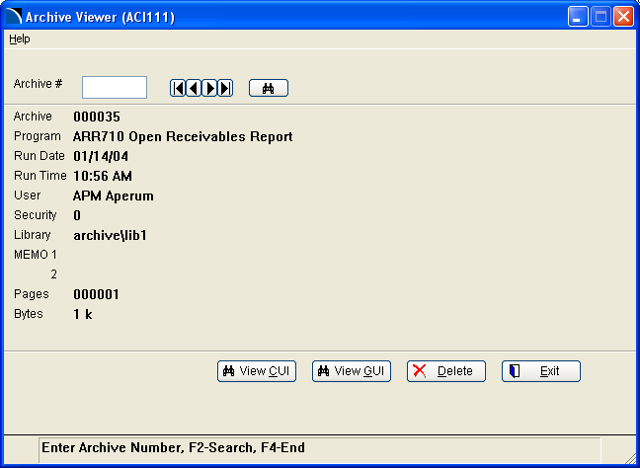

VIEW CUI Takes the user into our popular character based view mode.

VIEW GUI Uses PVX graphical view mode.

DELETE Allows the user to delete the Archive. A password is required for removal.

NEXT Locates and displays the attributes of the next available ARCHIVE
number.

<F4> or Exit Exits to a menu.

HELP This drop down menu has three options: Viewer Tips, GUI Options, and About Archive.
The GUI option allows the user to select their choice of a GUI type viewer.
ARCHIVE View (ACI111) (View Mode-Graphical Interface)

The graphical view mode utilizes an interface to either the FACTS 7.4 viewer or Word Pad. From within either method you can scroll up and down and left and right to view the report. There are also options to search for text, zoom in, and print to an attached PC printer. The Word Pad option allows the user to save the Archive on their PC in a rich text format.

ARCHIVE View (ACI10 and ACI111) (View Mode-Character Interface)

The view mode within ARCHIVE GUI and CUI View allows the user to view and search on ARCHIVED output of up to 255 columns wide, all in an easy to read, 80 column environment. Arrow keys and option codes control the display, as well as the search and print functions. Upon entering the view mode, the first screen of output is displayed (columns 1-80). The options available to the user include...

Option Code Enter one of option codes detailed below or enter ‘O’ to display a
selection box with the following options.

C Move to column n.
L Move to the left n columns.
LM Move to the left margin.
R Move to the right n columns.
RM Move to the right margin.
U Move up 1 screen (16 lines).
D Move down 1 screen (16 lines).
G Go to page output page n.
GF Go to the first output page (the beginning of the ARCHIVE).
GL Go to the last output page.
PP Print specific pages of the output.
PA Print all pages of the ARCHIVE.
SF Search Forward.
SA Search from the beginning of the ARCHIVE.

<CR> Display the next 16 lines of the text. If the end of the ARCHIVE is
reached, <CR> will begin redisplaying the ARCHIVE from the beginning.
<F2> Initiate a text search. The user will be asked if the search should move forward from the current position, or start from the beginning. The user will also be prompted to enter a text string to search for. The search performed here is case sensitive. If the search text is found, it is highlighted on the screen and displayed within the context of the original output. Subsequent searches will default to the previous search text, if not overridden.
<F3> Print using FACTS printers. A page range may be entered for a partial print.
<F4> Return to the attribute display screen.

<Left Arrow> Move the view to the left margin.
<Right Arrow> Move the view to the right margin.
<Up Arrow> Move the view up 1 row.
<Down Arrow> Move the view down 1 row.

ARCHIVE Print (ACP110)
The ARCHIVE Print program allows users to print one or more entire ARCHIVED output files to a system printer. The user simply enters the ARCHIVE numbers for those files that are to be printed. If multiple numbers are entered, they will be displayed individually below the input field.

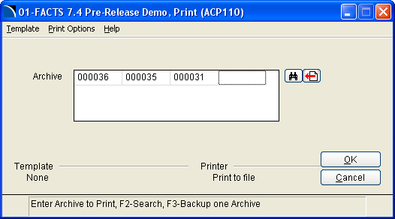

ARCHIVE Number - Enter a valid, 6 digit, ARCHIVE Number. A search by program
designation is available.

This program prints each ARCHIVE file, in its entirety, directly from the library to the selected printer. If the output is more than 132 columns wide and the output device is not capable of accepting over 132 characters per line, the ARCHIVE print will force the lines to wrap automatically.

ARCHIVE Store (ACU110)

The ARCHIVE Store program allows users to ARCHIVE text data not created via standard FACTS, including output from report writers, word processors, spreadsheets, etc.

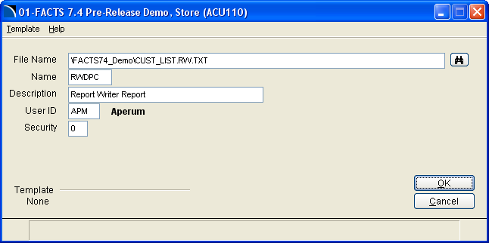

File Name - Enter the file name, including the full directory path, of the file to be stored. ARCHIVE will check the contents of the file and disallow any non-text file. A search option is available.

File Id- Enter a five character code as a secondary lookup to the ARCHIVE #. The id entered will be prefixed with "z", to force non-FACTS Archives to appear together within the ARCHIVE Search and ARCHIVE Listing.

Description - Enter up to a 30 character description for ARCHIVE Catalog purposes. The entry made in this field will be displayed where the program description is typically shown.

User Code - Enter the user code to assign to the ARCHIVE Catalog for this file. The
default user code will be the user code of the person initiating the
ARCHIVE.

Security Level - Enter a security level, 0 through 9, to assign to the ARCHIVE to control access to the stored output.

ARCHIVE Store then proceeds by displaying the standard ARCHIVE Set Up window, which prompts the user to enter memo lines regarding the ARCHIVE and to select a library directory in which to store the file. Once entered, the file is copied to the library and a Catalog F/M record is created.
ARCHIVE List (ACR110)

The ARCHIVE List program allows users to print a listing of all Archives. The user has the option to include memos and disk file names on the listing, if he/she so desires. Since this listing is generated off of the catalog file, libraries for the respective Archives are checked to verify the existence of the stored output. If the ARCHIVE is not found, the listing will notify the user. The selection criteria screen for this program appears as follows...

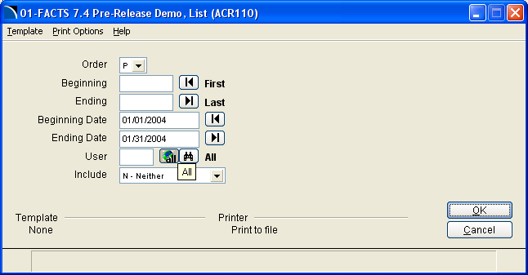

Follow these steps to run the ARCHIVE Listing.

1 Select the order in which to list the ARCHIVE Catalog information. Selecting 'A' allows the list to be run by a range of ARCHIVE numbers, while choosing 'P' will order the listing by FACTS program designation. Non-FACTS Archives have a program designation beginning with "z".

2 Depending on the order selected in step 1, enter the appropriate beginning criteria. If the ARCHIVE #/ program designation is on file, a description will print to the left. The default is the first record found.

3 Depending on the order selected in step 1, enter the appropriate ending criteria. If the ARCHIVE #/program designation is on file, a description will be printed to the left. The default is the last record found.

4 Enter the beginning run (ARCHIVE creation) date to include. The default is the earliest possible run date.

5 Enter the ending run date to include. The default is the latest possible run date.

6 Select options to include on the listing. Enter ‘M’ to include memos, ‘D’ to include the disk file name, or ‘A’ to include all of the above.

7 Enter a user code to include. If a user code is entered here, the listing will only contain Archives created by that user that fall within the parameters selected above.

8 Select options to include on the listing. M for Memos, D for disk file names, N for neither, or B for both. The default is neither.

The standard ARCHIVE Listing includes the ARCHIVE #, program designation and description, the date and time of creation, and the user code and name of the user who created the ARCHIVE, as well as the FACTS security level on the program at the time of the ARCHIVE, and the Archives actual size (in bytes) as it exists in the library directory. If either of the two include options is selected, the optional info is printed below the line of data mentioned above. A column is also included to denote whether or not an index file currently exists for the ARCHIVE. At the conclusion of the report, a recap is printed displaying the number and size (in bytes) of Archives included on the listing, broken down by library directory.
ARCHIVE Indexer (ACU130)

The ARCHIVE Indexer program allows users to pre-index one or more Archives in anticipation of viewing the ARCHIVE at a later time. The larger the ARCHIVE, the more time required creating the temporary index file used to facilitate the view mode. This program allows a user to create index files in the working directory ahead of time, so that the Archives are ready for immediate access with no delays.

ARCHIVE Number - Enter a valid, 6 digit, ARCHIVE Number. A search by program
designation is available.

This program indexes each ARCHIVE file, where it remains until removed by the view program, or by the UNIX administrator. (See installation notes re: working directory maintenance.)

ARCHIVE Backup (ACU160)
Not available in Windows/NT.

The ARCHIVE Backup program uses an interface identical to the ARCHIVE Removal program to allow users to backup selected Archives to tape or diskette. The selected Archives, along with a Catalog F/M log are uploaded to the storage media, from which they may be restored by ARCHIVE number using the ARCHIVE Restore program.

Processing:

- After the selection criteria are entered, the program logs each file to be backed up, as it copies the Archives to the backup directory.

- The user is then prompted to load the backup media and press <CR>.

- The files are then uploaded to the media, removed from the library directories, and deleted from the Catalog F/M.

* Users should consider printing an ARCHIVE Listing of the Archives to be backed-up, prior to running this program. The listing should be stored with the media for future reference.

ARCHIVE Restore (ACU180)
Not available in Windows/NT.

The ARCHIVE Restore program will reinstate previously backed up ARCHIVES to view status.

Processing:

- Upon entering the program, the restore directory is checked for an existing backup catalog file (from a previous restore session). If found, the user is given the option to restore from the existing file, or download from a new tape/diskette. If the user decides on new media, he/she is prompted to insert the media in the specified device and the backup catalog file is downloaded.

- Upon completing the download of the backup catalog file, the user selects, through a search window, each of the Archives to restore from the current media.

- The specific Archives are then extracted from the media and restored to their original, pre- backup status.
ARCHIVE Catalog Rebuilder (ACU140)

The ARCHIVE Catalog F/M Rebuilder will allow a user to re-create Catalog F/M records
that may have been inadvertently deleted, or may have been corrupted.

Processing:

- The user selects one of the valid library directories defined within the ARCHIVE Control F/M.

- Upon selection, the library will be scanned for valid catalog records.

- If a catalog record is missing the user will have the option to create a new record.

Most users will never require use of this program. Its effective use will be limited to the scenarios mentioned above. If an ARCHIVE Catalog F/M record is removed through the F/M, or through the removal program, the associated ARCHIVE file is removed as well, thus making it impossible to rebuild the catalog record from data maintained in the ARCHIVE file.

ARCHIVE Removal (ACU120)

The ARCHIVE Removal program allows users to remove unwanted or outdated ARCHIVES. This program will remove both the catalog record and the ARCHIVE file.

Follow these steps to run the ARCHIVE Removal.

1. Select the order by which to remove ARCHIVES. Selecting 'A’ allows the removal to be run by a range of ARCHIVE numbers, while choosing 'P' will order the removal by FACTS program designation. Non-FACTS Archives have a program designation beginning with "z".

2. Depending on the order selected in step 1, enter the appropriate beginning criteria. If the ARCHIVE #/ program designation is on file, a description will print to the left. The default is the first record found.

3. Depending on the order selected in step 1, enter the appropriate ending criteria. If the ARCHIVE #/program designation is on file, a description will be printed to the left. The default is the last record found.

4. Enter the beginning run (ARCHIVE creation) date to remove. The default is the earliest possible run date.

5. Enter the ending run date to remove. The default is the latest possible run date.

6. Enter a user code to remove Archives for. If a user code is entered, the program will only remove Archives created by that user that fall within the parameters selected above. The default is to remove Archives created by all users.

The ARCHIVE Removal program will remove all catalog records and ARCHIVE files that meet the criteria selected above.

Caution: This program should only be run under the supervision of a system administrator to reduce the chances of ‘accidental’ deletions. It is also suggested that FACTS security levels and/or passwords be set appropriately for this program. (This program does not require entry of the deletion password defined in the ARCHIVE Control F/M, since FACTS provides an adequate means of securing it.)
Archive FM’s and Utilities

This sub menu of the Archive system contains the following FM’s and Utilities

ARCHIVE Catalog FM – Maintain individual ARCHIVE records.
ARCHIVE Control FM – Set ARCHIVE system parameters.
ARCHIVE GUI Search Control FM – Set GUI search control parameters.
Make Text File From an Archive – Utility to make a .txt file from an Archive.
Text Pattern Search – Search archives for a text pattern match.
Move Archives – Move archive files from one library to another.

ARCHIVE Catalog F/M (ACF115)

The ARCHIVE Catalog F/M maintains records containing the attributes of each
ARCHIVED output file. The records appear as follows...

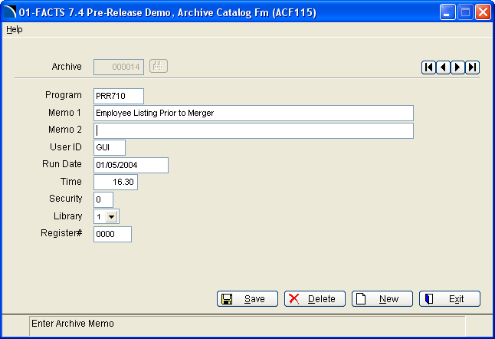

1. ARCHIVE # - Six digit sequential numbers are assigned to each ARCHIVE created, using the LAST ARCHIVE # USED field from the control record to determine the next number. If a specific ARCHIVE number is known, it can be entered here to retrieve the attributes of the ARCHIVED data. A search by program designation is also available.

2. PROGRAM - This field contains the FACTS program designation for FACTS output, or a user supplied identifier, beginning with "z", for nonFACTS ARCHIVES. The program description is displayed to the left of the program name/id. A search of FACTS programs is also available.

3. MEMO 1 - When the ARCHIVE 'printer' is selected, the user has the option to enter two 60 character memo lines to further describe the ARCHIVE. If memos were entered upon creation, they may be edited here. If no memo lines were entered initially, they may be added here. (The MEMO 1 field, by default, will contain the text "*Job Stream*" if the ARCHIVE was created during a Job Stream run.)

4. MEMO 2 - See Above.

5. USER CODE - This field should contain the user code for the creator of the ARCHIVE, with the full name of the user displayed to the left. This field may be changed to any currently valid user code.

6. RUN DATE - The ARCHIVE creation date is stored in this field, and may be changed to any valid date, if necessary.

7. RUN TIME - The field contains the time that the ARCHIVE was started on the date listed above. Data for this field is entered and stored in 24-hour time, using fractional hours (ex. 4:30 PM would be entered and stored as 16.50). The data is formatted to a standard time format for display.

8. SECURITY - The initial value of this field is the security level of the FACTS program as it was at the time of ARCHIVE creation. This level may be changed at any time to meet the security requirements of the host system.

9. LIBRARY - This field should contain one of the six ARCHIVE storage directories defined in the ARCHIVE Control F/M. A selection box is included for manual entries.

10. REGISTER # - This field stores the register number for archived registers (if applicable.)

If an ARCHIVE is called up within this program, the existence of the actual ARCHIVE output file will be verified. The user will be warned if the ARCHIVE file is not found.

If a user chooses to delete an ARCHIVE from this program, he/she will be prompted to enter the removal password. If the correct password is entered, both the ARCHIVE file and its associated catalog record will be removed.
ARCHIVE Control F/M (ACF995)

The ARCHIVE Control F/M contains the static and nonstatic control fields for the subsystem. The control record for the MAIN tab appears as follows...

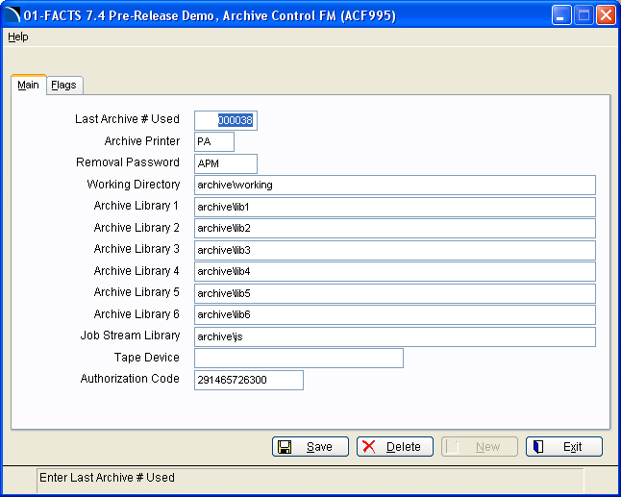

1. LAST ARCHIVE # USED - Each ARCHIVE is assigned a unique, six digit number for identification purposes. This counter is increased each time a new ARCHIVE is created.

2. ARCHIVE PRINTER - The ARCHIVE Sub-System requires a special link file to be defined within the ProvideX utilities. The default standard is “PA.” That link file should be entered here. (See the installation instructions for more info on setting up the link file).

3. REMOVAL PASSWORD - The removal password provides an additional safety net against ‘accidental’ deletions from within the ARCHIVE Index F/M and the Archive viewer. This password is NOT checked in the removal program, since FACTS provides more than adequate security capabilities.

4. WORKING DIRECTORY - ARCHIVE uses a working directory to create temporary ‘index’ files to enhance the speed and functionality of ARCHIVE View. The working directory is also used as the base directory for the backup/restore directories. Do not share a working directory for all companies. Must be unique for each company in FACTS.

5.-10. LIBRARY 1-6 - The ARCHIVE Sub-System provides users with up to
six different directories, or libraries, in which to store ARCHIVEd output (non-Job Stream). If a directory name is entered that does not exist, ARCHIVE will attempt to create it, if the user so desires. Do not share libraries for all companies. Must be unique for each company set up in FACTS.

11. JOB STREAM LIBRARY - To allow Job Stream to maintain its automated nature, all output from Job Stream runs is directed to this default library directory. Do not share the Job Stream Library for all companies. Must be unique for each company set up in FACTS.

12. TAPE DEVICE NAME - The backup and restore functions direct output to and from a storage device. ARCHIVE uses the tar command, and expects a true device file (ex. /dev/rmt0, /dev/fd1135dsl8, etc.) to be entered here. Typically tape or diskette drives are used for this function. Not available for Windows/NT.

13. AUTHORIZATION CODE - A valid ARCHIVE authorization code is required to store ARCHIVEd output.

Flags Tab Screen …

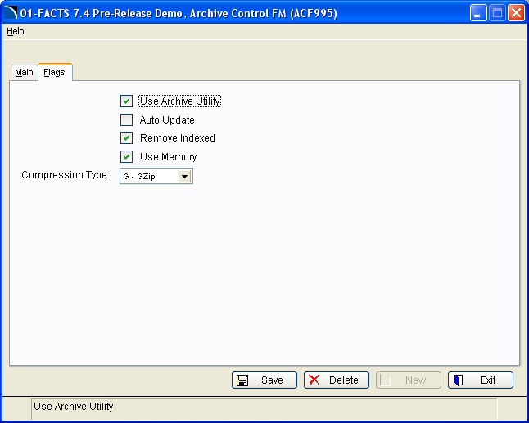

1. USE ARCHIVE UTILITY - This flag must be set to ‘Y’ before the ARCHIVE ‘printer’ device may be selected, thus allowing an ARCHIVE to be created. If the flag is set to 'N', only the Archives creation program is affected, allowing previously stored data to be viewed and printed as normal.

2. AUTO UPDATE - This flag controls whether or not the user is given the option to abort the update upon the completion of the 'print.' If set to ‘Y', the ARCHIVE is filed in the selected library upon completion of the output program. If the flag is set to 'N', then the user must enter a 'Y' to 'complete' the ARCHIVE, or 'N' to abort and remove the index record. Note: If an error occurs, or an escape is detected, the user will be given the above option, regardless of the value of the auto update flag.

3. REMOVE INDEXED - This flag controls whether or not temporary index files are retained in the work directory, or whether they are deleted upon exiting the view program. This is a time saver if Archives are accessed more than once a week or so. If set to 'N', please review the installation instructions on how to have the UNIX administrator to perform the cleanup of the temporary index files.

4. USE MEMORY - This flag controls whether or not indexing is performed via a memory
file.

5. COMPRESSION TYPE - ARCHIVE supports both the pack/unpack and compress/uncompress command sets available in Unix/AIX. The archive system also supports the use of gzip for many OS types, including Windows and Unix/AIX. Gzip is freeware. Any user who wishes to use this compression method should go the gzip web site at www.gzip.com , and download the proper OS type before turning this flag on.

ARCHIVE GUI Search Control F/M (ACF120)

The ARCHIVE GUI search control contains flags that enhance the GUI search program

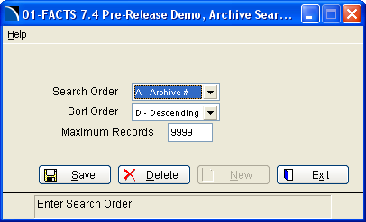

- SEARCH ORDER – The search appear in archive number order or program order.

- SORT ORDER – Sort either in ascending or descending. (Oldest to newest or newest to oldest)

- MAXIMUM RECORDS – The number of records to load at a time. If set to 9999 then all records will load.

ARCHIVE Utilities

The following utility programs have been added to the FM and Utility menu. These utility programs are basic programs and should only be used by a system administrator or an individual who is very familiar with the system. It is advisable that these programs be password protected

Make A Text File an Archive (ACU992) – This utility will a user to make a txt file with a .txt extension. The user will be prompted for the full path of the archive and for the new text file to make.

Text Pattern Search (ACU993) – This program allows users to search an archive library for text pattern match. The results of the search will be written to a text file. Afterwards users can either use the Archive Store program to make it into an archive file, or they can use the text file print program under SM reports to print it.

Move Archives (ACU995) – This utility allows users to move archive files from one library to another. Its main purpose is to assist with upgrades. Especially when new hardware systems are installed. The program gives instructions on the steps required to perform the move.

NOTE: Use of this program requires the knowledge of OS commands.

